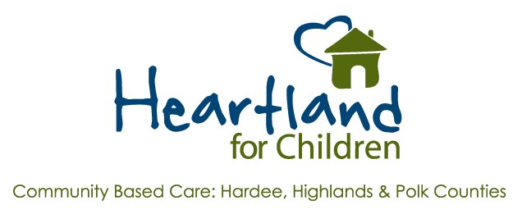

Intent to Award Notice for
EMERGENCY ITN
#FY21/22-001
Case Management Services
Official Posting Date and Time: Thursday, March 10, 2022 at 9:00 am
After careful consideration of all written responses received from the respondents, review of agency past performance in providing the advertised service, and one on one meetings with the top ranked respondents, Heartland for Children, Inc. hereby announces its intent to award the contract for services advertised in Emergency ITN #FY21/22-001 to the following agency:
Lutheran Services Florida, Inc.
Please note that this and all other postings are secondary to the electronic posting on www.heartlandforchildren.org, which is the sole official posting for this advertisement. Communication of any protest regarding this advertisement must be made to the HFC Procurement Manager and documented within 72 hours of the first official posting which is noted above. Physical posting will not extend that 72-hour deadline. Likewise, it is the responsibility of those submitting a response to this advertisement to obtain the results from the www.heartlandforchildren.org official posting site in sufficient time to protect their own interests should they care to do so.

