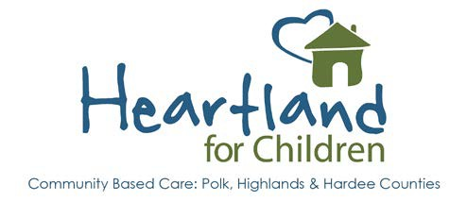

Educational Advocacy Training

Please view the Educational Advocacy Video and complete the attached quiz (per person).
*Please note our interim Education Specialist Kadian Parchment * Lisa Myers, Prevention Specialist
Address: 1239 East Main Street/Bartow, FL 33830
Desk: (863)519-8900 x292
Mobile: (863)370-5174
Fax: (863)519-8693
lmyers2@heartlandforchildren.org

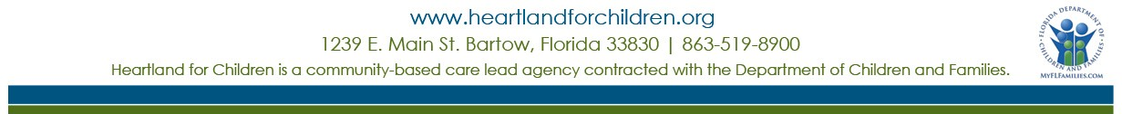

Educational Advocacy for Caregivers Quiz

Name: Date:

- ESSA (Every Student Succeeds Act) means that children in out-of-home care who change homes:
  - Are able to remain in their same school.
  - Can receive transportation to remain in their same school.
  - Require an ESSA staffing before they can change schools.
  - All of the above

- Schools should be provided with the following information:
  - My contact information as the child’s caregiver.
  - Case Manager and Guardian Ad Litem information.
  - Court Documentation.
  - All of the above

- When I have a concern for how a student in my home is doing in school, I can:
  - Talk to the teacher, case manager, therapist, guardian ad litem, or the biological parent.
  - Request a Problem Solving Team Meeting through the school counselor.
  - Request a meeting to review the IEP/504 Plan/Behavior Intervention Plan (if one is already in place).
  - All of the above

- An IEP (Individualized Education Program) and a 504 plan:
  - Require that the student have a disability to qualify.
  - Provide accommodations to students with disabilities.
  - Require that a student have a manifestation hearing if they are suspended beyond 10 days total within a school year.
  - All of the above.

- If I have an education related concern or question, I can contact:

Heartland for Children is a community-based care lead agency contracted with the Department of Children and Families.

